**Sustainable Development and Management**

***Syllabus***

Climate change - Global, Regional and local environmental issues and possible solutions - case studies. Concept of Carbon Credit, Carbon Footprint. Environmental management in industry - A case study.

***Contents***

4.7 Ozone Layer Depletion

4.8 Carbon Credit

4.9 Carbon Footprint

4.10 Two Marks Questions with Answers

# **Climate Change**

The average weather of a particular place is called as climate.

**Climate Change**

• The average weather of a particular place is called as climate.

• The earth's climate is changing dramatically because of human intervantion. The climate is influenced directly by temperature and other metrological conditions such as wind, precipitation and glaciation.

• Long term variation in temperature is major cause of climatic change in environment.

**1. Causes of Climatic Changes**

1. Presence of green house gases in atmosphere.

2. Depletion of ozone layer.

# **Ozone Layer Depletion**

Ozone (O3) is a gas found in atmosphere. Ozone is highly concentrated in stratosphere which lies about 15 - 50 km above the earth's surface. This is known as ozone layer.

**Ozone Layer Depletion**

• Ozone (O3) is a gas found in atmosphere. Ozone is highly concentrated in stratosphere which lies about 15 - 50 km above the earth's surface. This is known as ozone layer.

• The ozone in stratosphere protects living organisms from the ultraviolet radiation of the sun. In particular, it absorbs ultraviolet (UV) radiations and screens out harmful UV radiations.

**1. Hole in Ozone Layer**

• The amount of ozone present in atmosphere is delicate balance between the maning and destruction of ozone that depends upon the existence of naturally occuring trace compound.

• If some unnatural compounds are added to this balance that can provide extra catalytic species, then the destruction of ozone will be enhanced. This situation is known as hole in the ozone layer or depletion of ozone layer.

**2. Ozone Depleting Substances**

• Ozone layer is very much destroyed by the catalytic reactions having free radicals such as clorine (Cl), bromin (Br), hydrogen (H) and nitric oxide (NO).

• Following gases causes depletion of ozone in atmosphere

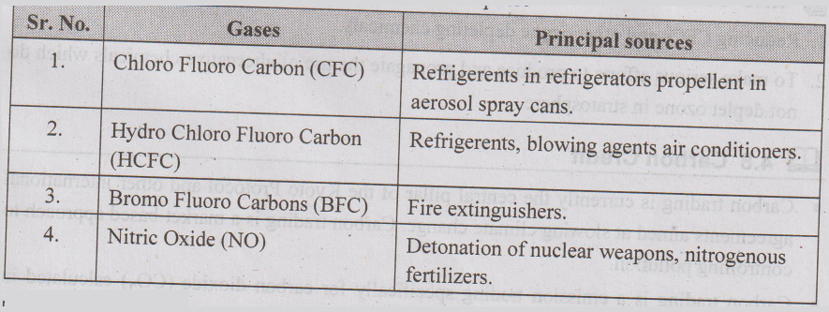

**3. Impact of Ozone Layer Depletion**

• Effect / impact or consequences of ozone layer depletion are :

**1. Effects on human health**

UV rays damage genetic material in skin causing skin cancer.

Prolonged exposure to UV rays may cause blindness.

Human resistivity is reduced resulting in allergies and infections.

**2. Effects on aquatic system**

Kills lower fauna and flora

Affects photosynthesis process cause mutation.

**3. Effect on materials**

Degradation of point quality and plastics.

**4. Effects on climate**

Climate change.

Global warming.

**4. Measurement of Ozone / Dobson Unit**

• The amount of atmospheric ozone is measured by "Dobson spectrometer" and is expressed in Dobson Units (DU).

• One Dobson Unit (1 DU) is equivalent to 0.01 mm thickness of pure ozone at the density is poses it is brought to ground level (1 atm) pressure.

• In temperature latidue concentration of ozone is 350 DU and in tropics it is 250 DU.

**5. Control Measures for Depletion of Ozone Layer**

1. Reducing CFCs and other ozone depleting chemicals.

2. To make serious efforts to produce and propagate the use of alternative chemicals which do not deplete ozone in stratosphere.

# **Carbon Credit**

**Carbon Credit**

• Carbon trading is currently the central pillar of the Kyoto Protocol and other international agreements aimed at slowing climate change. Carbon trading is a market-based approach to controlling pollution.

• Carbon trading is a emission trading specifically for carbon dioxide (CO2) calculated in tonnes of carbon dioxide equivalent or tCO2e.

• Carbon trading is about the rights of greenhouse gas emissions. The idea is a response to the Kyoto Protocol. Under Carbon trading, a country having more emissions of carbon is able to purchase the right to emit more and the country having less emission trades the right to emit carbon to other countries.

• Both countries and companies can reduce their emissions below designated levels and sell this amount to a business or country with greenhouse gas emissions that are too high.

• The financial instrument used for this trade is called offset carbon/carbon credit which is equivalent to one metric ton of equivalent CO2 equivalent.

• Carbon credits are measured in tonnes of carbon dioxide: 1 Credit = 1 Tonne of CO2

• Difference between carbon footprints and carbon credits is: carbon offsets is total emissions where as carbon credits is total reduction in emission. Carbon credits are bought to compensate carbon footprints.

# **Carbon Footprint**

 "The carbon footprint is a measure of the exclusive total amount of carbon dioxide emissions that is directly and indirectly caused by an activity or is accumulated over the life stages of a product."

**Carbon Footprint**

• A carbon footprint is a measure of the amount of carbon dioxide emitted through the combustion of fossil fuels.

• The carbon footprint is total amount of greenhouse gases produced to directly and indirectly support human activities, usually expressed in equivalent tons of carbon dioxide (CO2).

**Definition**

• "The carbon footprint is a measure of the exclusive total amount of carbon dioxide emissions that is directly and indirectly caused by an activity or is accumulated over the life stages of a product."

**For a Product or Process**

• A carbon footprint is the total amount of CO2q and other greenhouse gases, emitted over the full life cycle of a process or product. It is expressed as grams of CO2 equivalent per kilowatt hour of generation (gCO2eq/kWh), which accounts for the different global warming effects of other greenhouse gases.

**For a Business Organisation**

• In the case of a business organization, it is the amount of CO, emitted either directly or indirectly as a result of its everyday operations. It also might reflect the fossil energy represented in a product or commodity reaching market.

• When you drive a car, the engine burns fuel which creates a certain amount of CO2 depending on its fuel consumption and the driving distance.

• When you heat your house with oil, gas or coal, then you also generate CO2. Even if you heat your house with electricity, the generation of the electrical power may also have emitted a certain amount of CO2.

• When you buy food and goods, the production of the food and goods also emitted some quantities of CO2.

• Your carbon footprint is the sum of all emissions of CO2, which were induced by your activities in a given time frame.

• Usually a carbon footprint is calculated for the time period of a year.

• The best way is to calculate the carbon dioxide emissions based on the fuel consumption. In the next step you can add the CO2 emission to your carbon footprint. Below is a table for the most common used fuels :

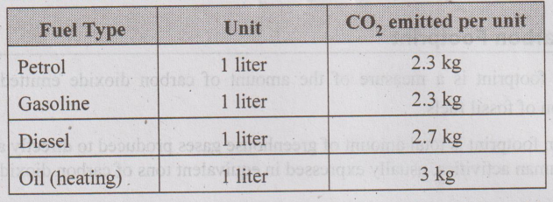

**• Example :** If your car consumes 7.5 liter diesel per 100 km, then a drive of 300 km distance consumes 3 × 7.5 = 22.5 liter diesel, which adds 22.5 × 2.7 kg = 60.75 kg CO2to your personal carbon footprint.

**1. Reducing Carbon Footprint**

• Carbon footprint can be reduced by several ways :

**1. Alternatives to driving -** When possible walk or ride your bike in order to avoid carbon emissions completely. Carpooling and public transportation drastically reduce CO2 emissions by spreading them out over many riders.

**2. Drive a low carbon vehicle -** High mileage doesn’t always mean low CO2 emissions. All vehicles have an estimated miles-per-gallon rating. Electric cars emit no CO2 if they’re charged with clean electricity.

**3. Driving style -** Speeding and unnecessary acceleration reduce mileage by up to 33 %, waste gas and money and increase your carbon footprint.

**4. Tyre inflation and other tuning -** Properly inflated tires improve your gas mileage by up to 3 %. It also helps to use the correct grade of motor oil and to keep your engine tuned, because some maintenance fixes, like fixing faulty oxygen sensors, can increase fuel efficiency by up to 40 %.

**5. Avoid traffic -** Being stuck in traffic wastes fuel and unnecessarily creates CO2. Use traffic websites and apps and go a different way or wait.

**6. Excess weight -** Remove excess weight from your car. Use cruise control.

**7. Reduce your carbon footprint from air travel -** Until petroleum-based aviation fuel is replaced, you should avoid flying when possible, fly less frequently, fly shorter distances and fly economy class.

Avoid air travel, instead increase your use of video-conferencing tools like Skype.

Economy class is best, for the same reasons as carpooling and public transportation. Each flyer’s share of a flight’s carbon emissions is relatively less because it’s spread out over more people.

**8. Don’t fly on private jets -** Fly first or business class if you must, because at least those seats always fill up anyway and avoid private jets.

**9. Insulate and seal your home -** Reduce drafts and air leaks with caulk, insulation and weather stripping.

**10. Appliances -** Make energy efficiency a primary consideration when choosing a new furnace, air conditioning unit, dishwasher or refrigerator. Products bearing the ENERGY STAR label are recognized for having superior efficiency.

**11. Lighting -** Turn off lights you’re not using and when you leave the room. Replace incandescent light bulbs with compact fluorescent or LED ones.

**12. Thermostat -** Don’t set it too high or low. Install a programmable model to turn off the heat/air conditioning when you’re not home.

**13. Solar -** Add solar panels to the roof of your home. This costs a little more than the above options, but many providers offer financing options which minimize upfront costs.

**14. Reduce your food carbon footprint from food -**Eat locally-produced and organic food. Buy local food that is naturally growing in season. Do you really need to eat strawberries flown in from the other side of the planet ? You want to eat fresh food, so what better that stuff growing locally.

It has been estimated that 30 % of greenhouse gas emissions result from the production and transport of food. Transporting food requires petroleum-based fuels and many fertilizers are also fossil fuel-based.

**15. Deforestation -** Deforestation is a top contributor to carbon emissions and thus climate change.

**16. Avoid partying -** This is for both food sustainability and economic inequality.

**17. Water usage -** Lower the amount of energy used to pump, treat and heat water by washing your car less often, using climate-appropriate plants in your garden, installing drip irrigation so that plants receive only what they need and making water-efficient choices when purchasing shower heads, faucet heads, toilets, dishwashers and washing machines.

Stop daydreaming in the shower and hurry up as lots of hot water is being wasted.

**18. Avoid buying bottled water -** Apart from being ridiculously expensive (it’s just water!) it may have travelled half way round the planet to get to you. Surely tap water in your own reusable container will do.

**19. Reuse and recycle -**It has been estimated that 40 % of greenhouse gas emissions result from the “provision of goods,” which means the extraction of resources, manufacturing, transport and final disposal of “goods” which include consumer products and packaging, building components and passenger vehicles, but excluding food. By buying used products and reselling or recycling items you no longer use, you dramatically reduce your carbon footprint from the “provision of goods.”

**20. Support clean energy sources -**Whenever you can, advocate for clean alternatives to fossil fuels, such as wind, solar, geothermal and appropriately designed hydroelectric and biomass energy projects.

21. Use fountain pen rather disposable plastic pens.

22. Do not put your supermarket vegetables into separate little plastic bags - it’s just a waste of bags. Use your own reusable bag to cart the entire goodies home.

23. Print on both sides of the paper and use recycled inks.

24. Use cleaning products that are not derived from oil - so look for vegetable based ones.

25. Wash your clothes at low temperatures, the detergents still work and the clothes don’t mind.

# **Two Marks Questions with Answers**

**Two Marks Questions with Answers**

**Q.1 What is EIA?**

**Ans. :**

• Environmental Impact Assessment (EIA) is the process of -assessing the likely environmental impacts of a proposal and identifying options to minimise environmental damage.

• The main purpose of EIA is to inform decision makers of the likely impacts of a proposal before a decision is made.

• EIA provides an opportunity to identify key issues and stakeholders early in the life of a proposal so that potentially adverse impacts can be addressed before final approval decisions are made.

• EIAs are essential for projects resulting in a major change in land use or located in environmentally sensitive areas.

• The clarity of environmental impacts identified, evaluated and mitigated is a measure of the adequacy and worth of an EIA.

**Q.2 Write the various uses of sustainable development indicators.**

**Ans.:**

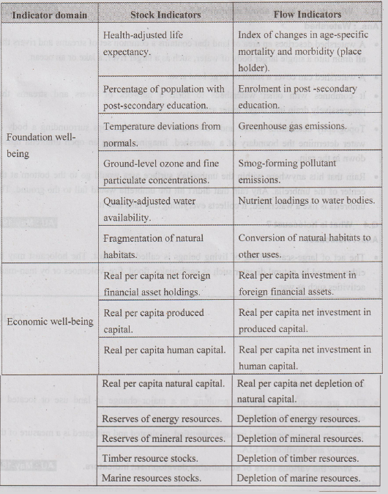

**Q.3 What do you know about watershed ?**

**Ans.: Watershed**

• A watershed describes an area of land that contains a common set of streams and rivers that all drain into a single larger body of water, such as a larger river, a lake or an ocean.

• A watershed can cover a small or large land area.

• It combines with other watersheds to form a network of rivers and streams that progressively drain into larger water areas.

• Topography determines where and how water flows. Ridge tops surrounding a body of water determine the boundary of a watershed. Imagine turning an open umbrella upside down in the rain.

• Rain that hits anywhere within the umbrella's surface area would go to the bottom at the center of the umbrella. Any rain that didn't hit the umbrella would fall to the ground. The umbrella is like a watershed; it collects everything that falls into it.

**Q.4 What is holocaust ?**

**Ans.: Holocaust**

• The act of large-scale killing of living beings is called holocaust. The holocaust may be either caused by natural disaster such as earthquake, flood, fire, volcanoes or by man-made activities such as war.

# **Sustainability Practices**

Zero waste and R concept, Circular economy, ISO 14000 Series, Material Life cycle assessment, Environmental Impact Assessment. Sustainable habitat : Green buildings, Green materials, Energy efficiency, Sustainable transports. Sustainable energy : Non - conventional Sources, Energy Cycles carbon cycle, emission and sequestration, Green Engineering : Sustainable urbanization - Socioeconomical and technological change.

**Chapter – 5**

**Sustainability Practices**

***Syllabus***

Zero waste and R concept, Circular economy, ISO 14000 Series, Material Life cycle assessment, Environmental Impact Assessment. Sustainable habitat : Green buildings, Green materials, Energy efficiency, Sustainable transports. Sustainable energy : Non - conventional Sources, Energy Cycles carbon cycle, emission and sequestration, Green Engineering : Sustainable urbanization - Socioeconomical and technological change.

***Contents***

5.1 Zero Waste

5.2 Concept of 5R (Refuse, Reduce, Reuse, Repurpose, Recycle)

5.3 Circular Economy

5.4 Quality System Standard ISO 14001: 2004

5.5 Sustainable Habitat

5.6 Energy Efficiency

5.7 Sustainable Transport

5.8 Sustainable Energy : Non-conventional Sources

5.9 Carbon Sequestration

5.10 Green Engineering

5.11 Urbanization

5.12 Low Carbon Life Cycle

5.13 Two Marks Questions with Answers

# **Zero Waste**

Zero Waste is a philosophy and a design principle for the 21st Century. It includes 'recycling' but goes beyond recycling by taking a 'whole system' approach to the vast flow of resources and waste through human society.

**Zero Waste**

• Zero Waste is a philosophy and a design principle for the 21st Century. It includes 'recycling' but goes beyond recycling by taking a 'whole system' approach to the vast flow of resources and waste through human society.

• To make recycling work for everyone, we need to buy products made from the materials we recycle. This reduces the need to utilize non-renewable resources by reusing materials that have already been consumed.

• Zero Waste means designing and managing products and processes to reduce the volume and toxicity of waste and materials, conserve and recover all resources and not bum or bury them.

• Producing recycled materials uses less energy and saves more trees than producing "virgin" materials.

• Implementing Zero Waste will help reduce discharges to land, water or air that may be a threat to planetary, human, animal or plant health and imitate sustainable natural cycles, where all discarded materials are resources for others to use.

• The zero waste approach seeks to maximize recycling, minimize waste, reduce consumption and ensures that products are made to be reused, repaired or recycled back into nature or the marketplace.

• Zero Waste systems reduce greenhouse gases by :

1. Saving energy - especially by reducing energy consumption associated with extracting, processing and transporting raw materials and waste.

2. Reducing and eventually eliminating the need for landfills and incinerators

**Goal of Zero Waste**

• The goal of Zero Waste is to :

1. Maximize recycling

2. Minimize waste

3. Reduce consumption

4. Ensure products are made to be reused, repaired or recycled

5. Purchase sustainable products

# **Concept of 5R (Refuse, Reduce, Reuse, Repurpose, Recycle)**

Incorporating this methodology into your business' waste reduction and recycling efforts will minimize landfill waste and help take your recycling program to the next level.

**Concept of 5R (Refuse, Reduce, Reuse, Repurpose, Recycle)**

• According to the 5 R's, four actions should be taken, if possible, prior to 'recycling': refuse, reduce, reuse, repurpose and then recycle.

• Incorporating this methodology into your business' waste reduction and recycling efforts will minimize landfill waste and help take your recycling program to the next level.

**1. Refuse :** Do not buy anything which we do not really need.

**2. Reduce :** Reduce the amount of garbage generated. Alter our lifestyle so that minimum garbage is generated.

**3. Reuse :** Reuse everything to its maximum after properly cleaning it. Make secondary use of different articles.

**4. Repurpose :** For every item that can't be refused, reduced or reused, try repurposing it. Many people in the green community refer to this method as upcycling. You may be surprised to learn how many common office products serve more than one purpose.

**5. Recycle :** Keep things which can be recycled to be given to rag pickers or waste pickers (Kabadiwallahs). Convert the recyclable garbage into manures or other useful products.

# **Circular Economy**

The circular economy is a systems solution framework that tackles global challenges like climate change, biodiversity loss, waste and pollution.

**Circular Economy**

• The circular economy is a systems solution framework that tackles global challenges like climate change, biodiversity loss, waste and pollution.

• In circular economy, products are designed for durability, reuse and recyclability and materials for new products come from old products.

• Circular economy is a new production and consumption model that ensures sustainable growth over time. With the circular economy, we can drive the optimization of resources, reduce the consumption of raw materials and recover waste by recycling or giving it a second life as a new product.

• The circular economy is important as it promotes sustainable development. It advocates using waste as an input for producing new finished goods.

• The circular economy supports creating reserves of raw materials and adopting innovative methods to eliminate any steps that reduce the cost and time to make new finished goods.

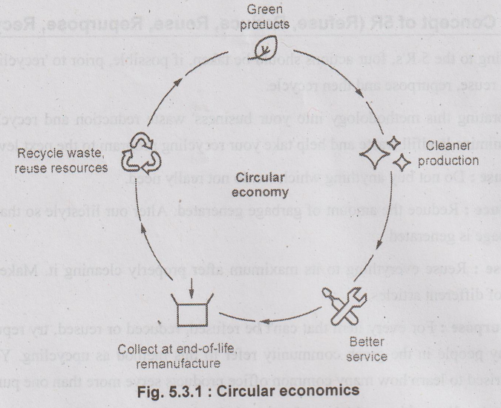

 1. Linear Economy Versus Linear Economy

• In a linear economy, materials flow in a straight line from resource extraction, to manufacturing and then to landfill.

• Value is created by producing and selling as many products as possible. This model is characterized by wasted resources and excessive pollution, causing ecosystem degradation, wealth concentrations and social inequities.

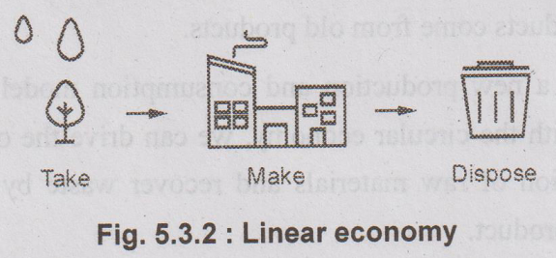

• A circular economy model, on the other hand, aims to redefine growth to benefit people and the planet. It entails gradually decoupling economic activity from the consumption of finite resources and designing waste out of the system.

• Underpinned by a transition to renewable energy sources, the circular business model builds economic, natural and social capital.

 2. Principles of Circular Economy

• The circular economy is based on three principles, driven by design :

1. Eliminate waste and pollution

2. Circulate products and materials (at their highest value)

3. Regenerate nature

 3. Benefits of Circular Economy

1. It reduces waste as it promotes the recycling of finished goods.

2. It offsets any potential price rise of the commodity.

3. Its adoption helps achieve efficiency and effectiveness as resources are recycled to get new products.

4. It promotes the rental business by advocating to reuse of an economic entity rather than purchasing a new entity.

# **Quality System Standard ISO 14001: 2004**

The purpose of ISO is to promote the development of standardization and related world activities in order to facilitate the international exchange of goods and services and to develop co-operation in intellectual, scientific technological and economic activities.

**Quality System Standard ISO 14001: 2004**

• The purpose of ISO is to promote the development of standardization and related world activities in order to facilitate the international exchange of goods and services and to develop co-operation in intellectual, scientific technological and economic activities.

• The ISO 14000 family addresses various aspects of environmental management. The very first two standards, ISO 14001:2004 and IS014004:2004 deal with environmental management systems (EMS).

• ISO 14001:2004 provides the requirements for an EMS and ISO 14004:2004 gives general EMS guidelines.

1. ISO 14000 Series Standards

1. ISO 14001 Environmental management systems-Requirements with guidance for use.

2. ISO 14004 Environmental management systems-General guidelines on principles, systems and support techniques.

3. ISO 14015 Environmental assessment of sites and organizations.

4. ISO 14020 series (14020 to 14025) Environmental labels and declarations.

5. ISO 14030 discusses post production environmental assessment.

6. ISO 14031 Environmental performance evaluation-Guidelines.

7. ISO 14040 series (14040 to 14049), Life Cycle Assessment, LCA, discusses pre- production planning and environment goal setting.

8. ISO 14050 terms and definitions.

9. ISO 14062 discusses making improvements to environmental impact goals.

10. ISO 14063 Environmental Communication-Guidelines and examples.

11. ISO 14064 Measuring, quantifying and reducing Greenhouse Gas emissions.

 2. Uses of ISO 14004:2004

• ISO 14004:2004 provides guidance on the establishment, implementation, maintenance and improvement of an environmental management system and its coordination with other management systems.

• An EMS (Environmental Management Systems) meeting the requirements of ISO 14001:2004 is a management tool enabling any organization to :

1. Identify and control the environmental impact of its activities, products or services.

2. Improve its environmental performance continually.

3. Implement a systematic approach to setting environmental objectives and targets, to achieving these and to demonstrating that they have been achieved.

# **Sustainable Habitat**

A Green building focuses on increasing the efficiency of resource use - energy, water and materials - while reducing building impact on human health and the environment during the building’s lifecycle, through better sitting, design, construction, operation, maintenance and removal.

**Sustainable Habitat**

• Sustainable Habitat is defined as an approach towards a balanced and sustainable development of the ecosystem of habitat which offers adequate shelter with basic services, infrastructure, livelihood opportunities along with environmental and socio-economic safety including equality, inclusiveness and disaster-resilience.

 1. Green Building

• A Green building focuses on increasing the efficiency of resource use - energy, water and materials - while reducing building impact on human health and the environment during the building’s lifecycle, through better sitting, design, construction, operation, maintenance and removal.

• Green Buildings should be designed and operated to reduce the overall impact of the built environment on its surroundings.

• Green buildings are designed to reduce the overall impact of the built environment on human health and the natural environment by :

1. Efficient use of energy, water and other resources.

2. Protecting occupant health and improving employee productivity.

3. Reducing waste, pollution and environmental degradation.

• Effective green buildings are more than just a random collection of environmental friendly technologies, however.

• They require careful, systemic attention to the full life cycle impacts of the resources embodied in the building and to the resource consumption and pollution emissions over the buildings complete life cycle.

 2. Planning for Sustainable Building

**1. Green building materials**

• Renewable plant materials like bamboo and straw, lumber from forests certified to be sustain ably managed, dimension stone, recycled stone, recycled metal and other products that are non-toxic, reusable, renewable and/or recyclable (e.g. sheep wool, panels made from paper flakes, compressed earth block, adobe, baked earth, rammed earth, clay, vermiculite, flax linen, sisal, seagrass, cork, expanded clay grains, coconut, wood fibre plates, calcium sand stone etc.)

• The EPA (Environmental Protection Agency) also suggests using recycled industrial goods, such as coal -combustion products, foundry sand and demolition debris in construction projects.

**2. Reduced energy use**

• Designers orient windows and walls ahd place awnings, porches and tress to shade windows and roofs during the summer while maximizing solar gain in the winter.

**3. Reduced waste**

• During the construction phase, one goal should be to reduce the amount of material going to landfills.

**4. Rain water harvesting**

• Rain water harvesting is done by collecting the water from terrace or roof and storing in underground tanks for using it in the summer months.

**5. Reduction of wastes and pollution**

• By collecting human waste at the source and running it to a semi-centralized biogas plant with other biological waste, liquid fertilizer can be produced.

 3. Advantages of Green Building

1. Green buildings harmonise with the local climate, traditions, culture and the surrounding environment.

2. Green buildings are designed to save energy and resources, recycle materials and minimise the emission of toxic substances throughout its life cycle.

3. Green buildings make efficient use of resources; have significant operational savings and increases workplace productivity.

4. Green buildings are able to sustain and improve the quality of human life whilst maintaining the capacity of the ecosystem at local and global levels.

5. Building green sends the right message about a company or organisation - that it is well run, responsible and committed to the future.

# **Energy Efficiency**

Energy efficiency is defined as the use of energy in an optimum manner to achieve the same service that could have been achieved using a common less efficient manner.

**Energy Efficiency**

• Energy efficiency is the use of less energy to perform the same task or produce the same result.

• Energy efficiency is defined as the use of energy in an optimum manner to achieve the same service that could have been achieved using a common less efficient manner.

• Energy efficiency is the practice of reducing the energy requirements while achieving the required energy output.

• Energy-efficient homes and buildings use less energy to heat, cool and run appliances and electronics and energy-efficient manufacturing facilities use less energy to produce goods.

• Energy efficiency is one of the easiest and most cost-effective ways to combat climate change, reduce energy costs for consumers.

• Energy efficiency is also a vital component in achieving net-zero emissions of carbon dioxide through decarbonization.

• Efficient use of energy can be understood in terms of using energy in such a way as to obtain the maximum benefit.

# **Sustainable Transport**

Energy efficiency is defined as the use of energy in an optimum manner to achieve the same service that could have been achieved using a common less efficient manner.

**Sustainable Transport**

• The sustainable transport definition can be best described as any type of transport that does not rely on the world’s natural resources to power it.

• Sustainable Transportation refers to any means of transportation that is green and has low impact on the environment.

• Sustainable transportation is also about balancing our current and future needs. Examples of sustainable transportation include walking, cycling, transit, carpooling, car sharing and green vehicles.

• Sustainable Transport is sometimes known as Green Transport and it is any form of transport that does not use or rely on dwindling natural resources. Instead it relies on renewable or regenerated energy rather than fossil fuels that have a finite life expectancy. For this reason it is said to have a low or a negative effect on the environment since it makes use of energy sources that are sustainable.

• Walking, cycling and sailing are excellent examples of sustainable transport.

• The sustainable transport definition can be best described as any type of transport that does not rely on the world’s natural resources to power it.

• Sustainable transportation options run on clean fuel, batteries or both. Alternative fuels can be used in flexible-fuel and dual-fuel vehicles as well as vehicles with advanced technology, such as hybrid power systems and fuel cells.

• Alternative fuels help conserve fuel and reduce emissions. They include :

a) Biodiesel

b) Electricity

c) Ethanol

d) Hydrogen

e) Natural Gas

f) Propane

 1. Benefits of Sustainable Transport

• Sustainable modes of transportation have several benefits. These include :

1) Reduced traffic congestion

2) Cost savings on fuel and vehicles

3) Reduced greenhouse gas emissions

4) Reduced dependence on non-renewable energy sources

5) Reduced transportation costs

6) Increased physical activity

7) Increased social interaction

8) Support for local businesses and a vibrant economy

9) Healthier lifestyles and a better quality of life

10) Improved accessibility to reliable, affordable transportation options for all.

# **Sustainable Energy: Non-conventional Sources**

The conventional sources of energy are generally non-renewable sources of energy, which are being used since a long time. These sources of energy are being used extensively in such a way that their known reserves have been depleted to a great extent.

**Sustainable Energy : Non-conventional Sources**

• The conventional sources of energy are generally non-renewable sources of energy, which are being used since a long time. These sources of energy are being used extensively in such a way that their known reserves have been depleted to a great extent.

• The sources of energy which are being produced continuously in nature and are in exhaustible are called non-conventional energy.

• Non-conventional sources are also known as renewable sources of energy.

• Various forms of renewable energy -

1. Solar energy

2. Wind energy

3. Bio energy

4. Hydro energy

5. Geothermal energy

6. Wave and tidal energy

# **Carbon Sequestration**

Carbon dioxide is the most commonly produced greenhouse gas. Around 45 % of the CO2 emitted by humans remains in the atmosphere, which is a significant factor behind global warming.

**Carbon Sequestration**

• Carbon dioxide is the most commonly produced greenhouse gas. Around 45 % of the CO2 emitted by humans remains in the atmosphere, which is a significant factor behind global warming.

• Carbon sequestration is the process of capturing, securing and storing carbon dioxide from the atmosphere.

• Carbon dioxide (CO2) Capture and Storage (CCS) is the idea to capture the CO2 from industrial processes like coal plants and then store it in deep geological formations.

• Carbon sequestration is one method of reducing the amount of carbon dioxide in the atmosphere with the goal of reducing global climate change.

• The idea is to stabilize carbon in solid and dissolved forms so that it doesn’t cause the atmosphere to warm. The process shows tremendous promise for reducing the human carbon footprint.

• Carbon sequestration is key method for removing carbon from the earth’s atmosphere.

• There are two main types of carbon sequestration :

1. Biological carbon sequestration and

2. Geological carbon sequestration

 1. Biological Sequestration

• Biological carbon sequestration happens when carbon is stored in the natural environment. This includes what are known as carbon sinks, such as forests, grasslands, soil, oceans and other bodies of water. This is also known as an indirect or passive form of sequestration.

**1. Forests**

• Forests and woodlands are considered one of the best forms of natural carbon sequestration. CO2 binds to plants during photosynthesis, exchanging it for oxygen as a purifying emission.

• On average, forests store twice as much carbon as they emit, while an estimated 25 % of global carbon emissions are sequestered alongside forests in other vegetative forms, such as grasslands or rangelands (fields, prairies, shrub lands etc.).

• Protecting such natural environments is therefore crucial to ensuring carbon sinks capture CO2 effectively. Deforestation poses the biggest threat to this natural process, as does construction or intensive agriculture.

**2. Soil**

• Through bogs, peat and swamps, carbon can be captured and stored as carbonates. These carbonates build up over thousands of years as CO2 mixes with other mineral elements, such as calcium or magnesium.

• Eventually, carbon is released from the earth, but not for a very long time - after more than 70,000 years in some cases.

**3. Oceans**

• Aquatic environments and large bodies of water are also great absorbers of CO2They absorb another estimated 25 % of emitted CO2from the earth’s atmosphere. This carbon is mostly held in the upper layers of the oceans.

• Too much carbon can acidify the water, posing a threat to the biodiversity that exists below - yet another reason to decarbonise our atmosphere.

 2. Geological Carbon Sequestration

• Geological carbon sequestration happens when carbon is stored in places such as underground geological formations or rocks. This process is largely artificial or direct, representing an effective way of neutralising emissions put into human practices, such as manufacturing or construction.

• It’s also largely technological as a result, with recent innovations showing carbon being sequestered more effectively on larger scales. They include :

**1. Graphene production :** The production of graphene requires CO2 as a raw material. Although limited to certain industries, it’s used heavily in the production of the tech devices we use on a day-to-day basis, such smartphones or computer processors.

**2. Engineered molecules :** A fairly new science, scientists can change the shape of molecules to form new compounds by capturing carbon from the air. In practice, this could present an efficient way of creating raw materials while reducing atmospheric carbon.

**3. Carbon Capture and Storage (CCS) :**CCS involves capturing carbon dioxide that’s been produced by power generation or industrial activity, such as cement or steel-making. This CO-, is then compressed and transported to deep underground facilities, where it’s injected into rock formations for permanent storage.

# **Green Engineering**

 Green Engineering can be defined as environmentally conscious attitudes, values and principles, combined with science, technology and engineering practice, all directed toward improving local and global environmental quality.

**Green Engineering**

• Green engineering is the design, commercialization and use of processes and products in a way that reduces pollution, promotes sustainability and minimizes risk to human health and the environment without sacrificing economic viability and efficiency.

• Green Engineering can be defined as environmentally conscious attitudes, values and principles, combined with science, technology and engineering practice, all directed toward improving local and global environmental quality.

• Green engineering utilizes engineering processes and methods that minimize pollution, improve a business' sustainability and decrease the potential for health issues caused by unsafe manufacturing and design methods.

• Green engineering embraces the concept that decisions to protect human health and the environment can have the greatest impact and cost-effectiveness when applied early, in the design and development phase of a process or product.

• Green Engineering is necessarily interdisciplinary and therefore, is best considered as a set of concepts which can be applied across engineering disciplines.

 1. Processes in Green Engineering

• Engineers may use many processes when green engineering, including :

**1. Waste reduction :**

• Many commercial processes, such as manufacturing and shipping products, may waste energy through inefficient manufacturing and delivery methods.

• Green engineering seeks ways to minimize this waste, including finding new fuel methods and minimizing unnecessary production steps that needlessly use energy.

**2. Materials management:**

• Materials management entails finding better and safer materials for diverse engineering purposes, particularly in product design and manufacturing.

• Engineers may identify new and safer materials or invent options to integrate into their plans and find better and more efficient production methods.

**3. Pollution prevention :**

• Pollution prevention focuses on identifying a company's pollution sources and minimizing their waste.

• Engineers may identify why pollution occurs, find processing methods that decrease its spread, integrate newer and cleaner techniques and enhance manufacturing and delivery cleanliness.

**4. Product enhancement:**

• Green engineers seek to improve the products or services they're engineering while making them safer for the environment.

• This process may include finding alternate energy sources that work better than traditional options or identifying greener and more efficient manufacturing materials and methods.

 2. Principles of Green Engineering

**1. Inherent Rather Than Circumstantial :**Designers need to strive to ensure that all materials and energy inputs and outputs are as inherently non-hazardous as possible.

**2. Prevention Instead of Treatment :** It is better to prevent waste than to treat or clean up waste after it is formed.

**3. Design for Separation :** Separation and purification operations should be designed to minimize energy consumption and materials use.

**4. Maximize Efficiency :** Products, processes and systems should be designed to maximize mass, energy, space and time efficiency.

**5. Output-Pulled Versus Input-Pushed :** Products, processes and systems should be “output pulled” rather than “input pushed” through the use of energy and materials.

**6. Conserve Complexity :** Embedded entropy and complexity must be viewed as an investment when making design choices on recycle, reuse or beneficial disposition.

**7. Durability Rather Than Immortality :** Targeted durability, not immortality, should be a design goal.

**8. Meet Need, Minimize Excess :** Design for unnecessary capacity or capability (e.g., “one size fits all”) solutions should be considered a design flaw.

**9. Minimize Material Diversity :**Material diversity in multicomponent products should be minimized to promote disassembly and value retention.

**10. Integrate Material and Energy Flows :** Design of products, processes and systems must include integration and interconnectivity with available energy and materials flows.

**11. Design for Commercial Afterlife :**Products, processes and systems should be designed for performance in a commercial afterlife.

**12. Renewable Rather Than Depleting :**Material and energy inputs should be renewable rather than depleting.

 3. Cradle to Cradle Concept

• Cradle-to-cradle (C2C) is a way of designing products or processes that work more like natural systems.

• Cradle-to-cradle is a term used in life-cycle analysis to describe a material or product that is recycled into a new product at the end of its life, so that ultimately there is no waste. Zero waste, Zero trash, Zero litter, Zero garbage, Nothing to throw away.

• Cradle to Cradle design refers to a production process where products are developed for closed-loop systems in which every output ingredient is safe and beneficial - either to biodegrade naturally and restore the soil (called a biological nutrient) or to be fully recycled into high-quality materials for subsequent product generations (called a technical nutrient).

• C2C design method is intended to replace a make-take-dispose approach which begins with new raw materials mined from the earth and ends with piles of garbage.

• C2C is used to minimise the environmental impact of products by employing sustainable production, operation and disposal practices and aims to incorporate social responsibility into product development.

# **Urbanization**

Urbanization is a process of moving population from rural areas to urban areas for improving life standards and life style through scientific and technological developments.

**Urbanization**

• Urbanization is a process of moving population from rural areas to urban areas for improving life standards and life style through scientific and technological developments.

• The energy related problems due to urbanization include -

**1. Pollution from coal:** The use of coal pollutes the environment.

**2. Acid rain :** Various industries are releasing harmful gases like sulphur oxides, nitrogen oxides which reacts with water or moisture in the environment produces sulphuric acid.

**3. Pollution from vehicle :** The exhausts from two-wheeler, four wheeler and other transport vehicles produces huge level of air pollution.

**4. Deforestation :** Human needs space to live hence this requirement is fulfilled by deforestation and building houses. Even after this human needs wood for house furniture and timber as fuel.

**5. Global warming :** Combustion of fossil fuels (oil, petrol, diesel, gas) produces harmful gases, which acts as green house i.e. short wave and natural light can pass but traps heat radiation hence overall environment temperature rises.

**6. Use of electricity :** Large amount of electricity is utilized for human comforts like - A/C, washing machine, refrigerator, water heater etc. Hence, electricity requirement is increasing day by day.

 1. Solution for Urban Energy Problem

1. Use of public transport instead of using private vehicles.

2. Reducing energy consumption in all respect.

3. Using energy efficient devices.

4. Encourging use of solar and wind energy.

5. Imposing strict laws, penalties and energy audits.

# **Low Carbon Life Cycle**

Low carbon lifestyles create less carbon dioxide emissions.

**Low Carbon Life Cycle**

• Low carbon refers to a minimal output of greenhouse gas emissions into the biosphere, specifically refers to the greenhouse gas carbon dioxide. So, low carbon life means a kind of lifestyle in which people do their best to reduce energy consumption and carbon greenhouse gas emissions. Low carbon economy is an economy model based on low energy consumption, low pollution and low emission.

• Low carbon lifestyles create less carbon dioxide emissions. Activities that create carbon dioxide are driving cars, heating homes, generating electricity, flying planes, making goods in factories and transporting things a long way.

# **Two Marks Questions with Answers**

**Two Marks Questions with Answers**

**Q.1 What is e-waste ?**

**Ans. : E-Waste :**

• The term "e-waste" is an abbreviation of electronic waste.

• E-Waste is a term used to cover items of all types of electrical and electronic equipment (EEE) and its parts that have been discarded by the owner as waste without the intention of re-use.

• E-waste is a general term, it can be considered to denote items such as TV appliances, computers, laptops, tablets, mobile phones, white goods - for example, fridges, washing machines, dryers - home entertainment and stereo systems, toys, toasters and kettles.

**Q.2 Write the concept of Green building.**

**Ans.:**

• A Green building focuses on increasing the efficiency of resource use - energy, water and materials - while reducing building impact on human health and the environment during the building's lifecycle, through better sitting, design, construction, operation, maintenance and removal.

• Green buildings should be designed and operated to reduce the overall impact of the built environment on its surroundings.

• Green buildings are designed to reduce the overall impact of the built environment on human health and the natural environment by :

1. Efficiently using energy, water and other resources.

2. Protecting occupant health and improving employee productivity.

3. Reducing waste, pollution and environmental degradation.

**Q.3 What is ozone depletion ?**

**Ans. :** Ozone depletion : Breakdown of the ozone shield (a thin layer of ozone gas molecules in the atmosphere) that can absorb damaging ultraviolet radiation and have major implications for global weather ; CFCs and halons greatly speed the process.

**Q.4 List out any four environmental protection acts.**

**Ans. :**1. Air (Prevention and control of pollution) Act.

2. Water (Prevention and control of pollution) Act.

3. Forest censervation Act.

4. Environmental lows.

**Q.5 What are the major effect of global warming ?**

**Ans.: Effects of global warming :**

1. Changes in climate.

2. Effect on agriculture productivity.

3. Effect on water resources.

**Q.6 List out the objective of EIA.**

**Ans.: Objectives of EIA :**

1. To identify the reasons of problem.

2. To identify the problems and issues of the parties.

3. To identify the affected parties.

**Q.7 Mention the effects of ozone on plants.**

**Ans. : Effects of ozone on plants**

1. Ozone enters through openings into the leaf and damage the cells that produce the food for the plant.

2. Once the ozone is abserbed into the leaf, plants may suffer from toxic effect and growth loss exists.

**Q.8 Define EIA and its benefits.**

**Ans. :** Environmental Impact Assessment (EIA) is the process of assessing the likely environmental impacts of a proposal and identifying options to minimise environmental damage.

**Benefits of EIA :**

1 EIA gives basis for better decision making.

2. EIA provides potential environmental effects.

3. Helps in formulation of projects.